**A PROJECT REPORT ON THE POWER GYM**

SUMMER TRAINING PROJECT



**SUBMITTED BY: SUBMITTED TO:**

**SURINDER SINGH MRS. KHUSHWANT**

**COURSE: BTECH VIRDI**

**ROLNO: 2027492**

**CLASS: C3**

**GLOBAL GROUP OF INSTITUTES**

**AMRITSAR**

DECLARATION

## I hereby certify that the work which is being presented in the project report entitled “THE POWER GYM” by “Sahil kumar and Surinder Singh” in partial fulfilment of requirements for the award of Btech in computer science engineering submitted in the Department of Computer Science and Engineering at “Global Group of Institutes, Amritsar” under IKG PUNJAB TECHNICAL UNIVERSITY, JALANDHAR is an authentic record of my own work carried out during a period from November 2021 to December 2021 under the supervision of Khushwant Virdi.

## (Signature of Student):

## Sahil kumar

## 

## 

## Certified that the above statement made by the student is correct to the best of our knowledge and belief.

## Signature of the SUPERVISOR (S):

## Head of Department:

## ACKNOWLEDGEMENTS

## The authors are highly grateful to Dr. M.S SAINI, Director, Global Group of Institutes, Amritsar, for providing this opportunity to carry out the project at GGI, Amritsar. The constant guidance and encouragement received from Mrs. Meenaxee Sharma (HOD, CSE Dept.) and Class incharge Mrs. Khushwant Virdi has been of great help in carrying out the project work and is acknowledged with reverential thanks. The authors would like to express a deep sense of gratitude and thanks profusely to Mrs. Khushwant Virdi. Without the wise counsel and able guidance, it would have been impossible to complete the report in this manner. The authors express gratitude to other faculty members of Computer Science Engineering Department, Global Group Of Institutes, for their intellectual support throughout the course of this work.

## Finally, the authors are indebted to all whosoever have contributed in this report work.

|  |  |  |
| --- | --- | --- |
| **SN NO.** | **TOPICS** | **PAGE NO.** |
| **1.** | Introduction to HTML | 1-11 |
| **2.** | Introduction to CSS | 12 |
| **3.** | Introduction to Project | 13-14 |
| **4.** | Project Snapshots | 15-19 |
| **5.** | Coding | 20- |
|  |  |  |

**TABLE OF CONTENTS:**

**INTRODUCTION TO PROJECT:**

A gym - physical exercises and activities performed inside, often using equipment, especially when done as a subject at school. Gymnasium is a large room with equipment for exercising the body and increasing strength or a club where you can go to exercise and keep fit.

A gym is a gymnasium, also known as health club and fitness centre. Gymnasiums have moved away just being a location for gymnastics. Where they had gymnastics apparatus such as bar bells, parallel bars, jumping boards and running path etc.

If you are looking to join a gymnastics club, please see gymnastics.

A health club, fitness centre is now commonly referred to as a gym.

**PROJECT OBJECTIVE:**

Going to the gym every day can help improve your cardiovascular system, strengthen your muscles, help you maintain your weight, boost your mental health and decrease the odds that you'll develop other health conditions.

Exercising daily [strengthens your heart](https://medlineplus.gov/benefitsofexercise.html) and allows it to pump more efficiently with less strain. It also keeps your blood pressure and [blood sugar levels](http://www.diabetes.org/food-and-fitness/fitness/get-started-safely/blood-glucose-control-and-exercise.html) in the normal range and keeps your cholesterol levels in check. Plus, it may help manage the symptoms of [depression and anxiety](https://www.mayoclinic.org/diseases-conditions/depression/in-depth/depression-and-exercise/art-20046495).

Daily gym workouts may also lower your risk of [developing certain conditions](https://www.cdc.gov/chronicdisease/resources/infographic/physical-activity.htm) such as type 2 diabetes, metabolic syndrome and osteoporosis.

**HTML:**

**INTRODUCTION TO HTML:**

HTML stands for Hyper Text Markup Language. It is a language for describing web pages. HTML is a **markup language** rather than a programming language and makes use of **HTML tags**to structure the content of your web pages. HTML is the **language in which most websites are written**.

**History of HTML:**

HTML was first created by Tim Berners-Lee, Robert Caillou, and others starting in **1989**.

It stands for Hyper Text Markup Language.

Hypertext means that the document contains **links that allow the reader to jump to other places** in the document or to another document altogether. The latest version is known as HTML5.

A **Markup Language** is a way that computers speak to each other to control how text is processed and presented. To do this HTML uses two things: tags and **attributes**.

**Advantages of HTML:**

The different advantages of HTML are:

1. HTML is easy to learn and use:

HTML is very easy to learn and understand. HTML is the first and foremost language that the person will go through for the one who is learning web development. It has simple tags, and there is no hectic of case sensitivity in HTML. It simply has some tags that serve a specific purpose.

1. HTML is free:

One of the biggest advantages of HTML is that it is free of cost, and there is no need to purchase specific software. One should not have to deal with different plugins required to work on any software as HTML does not require any plugins. So it is very cost-effective from a per business perspective as there is no cost of purchasing the license if the whole website is developed in HTML language.

1. HTML is supported by all Browsers:

HTML supports almost all browsers around the globe. So there is no need to worry about the website written in HTML for the browser support as the website would easily show up in all the browsers.

Similarly other advantages of HTML are:

* HTML is the Most-Friendly Search Engine.
* It is Simple to Edit.
* It is Lightweight.
* It is User-Friendly and so on.

**Versions of HTML:**

There are 5 different versions of HTML. They are:

1. HTML 1.0:

The basic version of HTML has support for basic elements like text controls and images. This was the very basic version of HTML with less support for a wide range of HTML elements. It does not have rich features like styling and other things that were related to how content will be rendered in a browser.

1. HTML 2:

HTML version 2.0 was developed in 1995 with basic intention of improving HTML version. Now, a standard got started to develop so as to maintain common rules and regulations across different browsers. HTML 2.0 has improved a lot in terms of the markup tags. In HTML 2.0 version concept of form came into force. Forms were developed, but still, they had basic tags like text boxes, buttons, etc. Also, the table came as an HTML Tag. Now, in HTML tag 2.0, browsers also came with the concept of creating their own layers of tags that were specific to the browser itself.

1. HTML 3.2:

It was developed in 1997. After HTML 2.0 was developed, the next version of HTML was 3.2With version 3.2 of HTML, HTML tags were further improved. It is worth noting that because of W3C standard maintenance, the newer version of HTML was 3.2 instead of 3. Now, HTML 3.2 has better support for new form elements. Another important feature what HTML 3.2 implemented was support for CSS. CSS stands for Cascading Style Sheet. It is CSS that provides features to make HTML tags look better on rendering it on browsers. CSS helps to style HTML elements. With the upgradation of browsers to HTML 3.2, the browser also supported for Frame Tags, although HTML specifications still do not support frame markup tags.

1. HTML 4.01:

It was developed in 1999. It extended the support of cascading styling sheets. In version 3.2, CSS were embedded in HTML page itself. Therefore, if the website has various web pages to apply to the style of each page, we must place CSS on each web page. Hence there was a repetition of the same block of CSS. To overcome this thing, in version 4.01 concept of an external styling sheet emerged. Under this concept, an external CSS file could be developed, and this external styling file could be included in HTML itself. HTML 4.01 provided support for further new tags of HTML.

1. HTML 5:

This is the latest version of HTML. For a developer, it could be used in 2014. It came with lots of HTML support. HTML5 provided support for new form elements like input element of different types; geolocations support tags, etc.

**Applications of HTML:**

1. Web pages development
2. Web document creation\
3. Internet navigation
4. Cutting edge feature
5. Responsive image on webpage
6. Client-side storage
7. Offline capabilities usage
8. Data entry support with HTML
9. Game development usage

**HTML Tags:**

Tags are used to **mark up the start of an HTML element** and they are usually enclosed in angle brackets.

An example of a tag is: <h1>.

Most tags must be opened <h1> and closed </h1> in order to function.

The Types of Tags are:

1. Html tag: <html></html>

The HTML tag, also called the root element, follows the DOCTYPE tag. This tag can have the normal global attributes plus an attribute called manifest. The HTML tag can only be used once on an HTML page. Everything HTML-related is nested inside this tag. This means that all of our tags will be located between the opening and closing of the HTML tags.

1. Head tag: <head></head>

The head tag provides general information about the web page that is being displayed. An individual tag is added inside of the head tag, which lets the browser know certain specifics, such as the title of the page, author of the page, and other such information.

1. Body tag: <body></body>

The body tag lets the browser know what to display on the page. Inside the body, the tag is where we will place all of our content, such as tags and text. Anything placed inside of the body tag will be displayed on the web page.

1. Paragraph tag: <p></p>

The paragraph tag, or the p tag, is used when you want to keep a paragraph of text together. This element is a block-level element, meaning it takes up the width of its parent container. The ideal use would be when you have a lot of text to display. Only global attributes are permitted for this particular element.

1. Underline tag: <u></u>

U stands for underline. This will underline any text within the open and closed tags.

1. Break tag: <br>

The BR tag standing for a break. There are a few tags that don’t need a closing tag. It’s neither block and inline element. It is a global attribute.

1. Tag-hr: <hr>

The hr tag also does not need a closing tag to complete it. The hr tag, which stands for the horizontal rule, will create a line on the web page. It’s a block-level element. It’s a global attribute.

1. Tag-li: <li></li>

The li tag standing for a list item is the tag that will be nested. Inside the li tag, you would put any type of content that is a list.

1. Tag-ol: <ol></ol>

The ol tag, standing for the Ordered List, is a container of the nested li tag. You will never see these two tags, the li or the ol tag, by themselves. Since this is a list of orders, that means next to each item in the list, there will be a value.

**HTML Attributes:**

HTML attributes can be said as special words which are used inside opening tags and are responsible for controlling an element’s behavior. They are a modifier of the HTML element type. This modifier can do two jobs. It can either modify the default functionality of an element or provide the functionality to any element that cannot function properly without them. Syntactically, an attribute is added to the HTML start tag. There are different types of attributes that have been identified. These include the required attributes, optional attributes, standard attributes, and event attributes. Required attributes are those which are needed by a particular element type so that the function works correctly.

Attributes contain **additional pieces of information**. Attributes take the form of an opening tag and additional info is **placed inside**.

An example of an attribute is:

<img src="mydog.jpg" alt="A photo of my dog.">

In this instance, the image source (src) and the alt text (alt) are attributes of the <img> tag.

The different types of Attributes are:

1. Tag H1, H2, H3, H4, H5, H6:

There are six total header tags. Each of these with its own number, starting at 1 down to 6.  The h1 tag and all the other header tags provide a brief description for a section of text or content. These tags are global attributes.

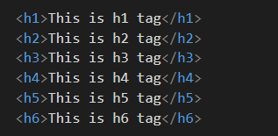

1. Tag img:

The img tag, or the image tag, gives us the ability to display images on our page.

<img src=””/>

Now you will notice in the example here that the image tag does not have a closing tag. This is one of the handfuls of tags. But unlike the br tag and the hr tag, we signify the ending of this tag with a forward slash. Some might actually refer to this as the shorthand way to write a closing tag.

The src attribute and the alt attribute. The src, or the source attribute, as you see in the example, is required.

Now the value of this attribute is the path to the photo we would like to display. The path can be either an absolute path or a relative path. The other attribute is the alt attribute. This stands for an alternative. The alt value should describe the photo. The alt text will be displayed in the browser as below.

Tag – img

1. Width and Height attribute:

This attribute can be used to adjust the height and width of an image.

Global Attributes:

HTML also provides global attributes which can be used with any HTML element. The attributes are as below.

* **Accesskey:** It specifies a shortcut key to activate or focus on any element.
* **Translate:** If this attribute is used, it specifies whether the content of the element is to be translated or not.
* **Class:** It specifies one or more class names for an element.
* **Title:** This attribute specifies extra information about an element.
* **Contenteditable:** In order to specify whether the content is editable or not, this attribute can be used.
* **Tabindex:** It specifies the tabbing order of an element.
* **Dir:** It specifies the text direction for any content of an element.
* **Spellcheck:** User can explicitly specify if they have to check the spelling and grammar checked or not.
* **Draggable:** It specifies if an element should be draggable or not.
* **Dropzone:** It specifies whether the dragged data is copied, moved or linked when dropped.

**INTRODUCTION TO CSS:**

**Cascading Style Sheets (CSS):**

Cascading Style Sheets (CSS) is a style sheet language used for describing the presentation of a document written in a markup language such as HTML.[1] CSS is a cornerstone technology of the **World Wide Web, alongside HTML and JavaScript**.

CSS is designed to enable the separation of presentation and content, including layout, colors, and fonts.[3] This separation can improve content accessibility; provide more flexibility and control in the specification of presentation characteristics; enable multiple web pages to share formatting by specifying the relevant CSS in a separate .CSS file, which reduces complexity and repetition in the structural content; and enable the .CSS file to be cached to improve the page load speed between the pages that share the file and its formatting.

Separation of formatting and content also makes it feasible to present the same markup page in different styles for different rendering methods, such as on-screen, in print, by voice (via speech-based browser or screen reader), and on Braillebased tactile devices. CSS also has rules for alternate formatting if the content is accessed on a mobile device.

The name cascading comes from the specified priority scheme to determine which style rule applies if more than one rule matches a particular element. This cascading priority scheme is predictable.

The CSS specifications are maintained by the World Wide Web Consortium (W3C). Internet media type (MIME type) text/CSS is registered for use with CSS by 8 RFC 2318 (March 1998). The W3C operates a free CSS validation service for CSS documents.

In addition to HTML, other markup languages support the use of CSS including **XHTML, plain XML, SVG, and** **XUL.**

Advantages of CSS:

1. Site-Wide Consistency:

When CSS is used effectively, in terms of inheritance and “cascading”, a global style sheet can be used to affect and style elements site-wide. If the situation arises that the styling of the elements should be changed or adjusted, these changes can be made by editing rules in the global style sheet. Before CSS, this sort of maintenance was more difficult, expensive and time-consuming.

1. Bandwidth:

A stylesheet, internal or external, specifies the style once for a range of HTML elements selected by class, type or relationship to others. This is much more efficient than repeating style information inline for each occurrence of the element. An external stylesheet is usually stored in the browser cache, and can therefore be used on multiple pages without being reloaded, further reducing data transfer over a network.

1. Page reformatting:

With a simple change of one line, a different style sheet can be used for the same page. This has advantages for accessibility, as well as providing the ability to tailor a page or site to different target devices.

**HTML CODE:-**

**LOGIN :-**

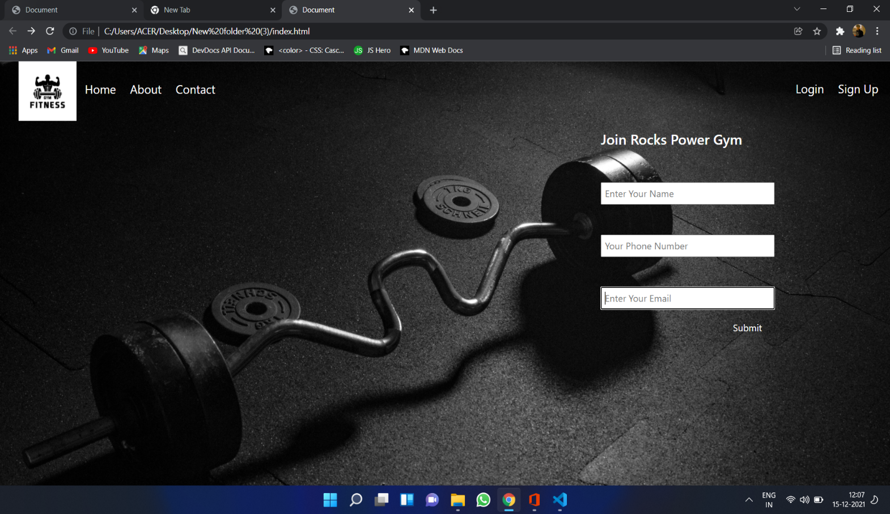

<!DOCTYPE html>

<html lang="en">

<head>

<meta charset="UTF-8">

<meta http-equiv="X-UA-Compatible" content="IE=edge">

<meta name="viewport" content="width=device-width, initial-scale=1.0">

<link href="https://cdn.jsdelivr.net/npm/bootstrap@5.1.3/dist/css/bootstrap.min.css" rel="stylesheet" integrity="sha384-1BmE4kWBq78iYhFldvKuhfTAU6auU8tT94WrHftjDbrCEXSU1oBoqyl2QvZ6jIW3" crossorigin="anonymous">

<link rel="stylesheet" href="styles.css">

<title>Document</title>

</head>

<body>

<nav class="right">

<ul>

<img src="logo.jpg" alt="logo" srcset="">

<li><a href="first.html">Home</a></li>

<li><a href="About.html">About</a></li>

<li><a href="contact.html">Contact</a></li>

<div class="left">

<li><a href="index.html">Login</a></li>

<li><a href="signup.html">Sign Up</a></li>

</div>

</ul>

<div class="container">

<h4>Join Rocks Power Gym</h4>

<form class action="">

<input type="text" name="" placeholder="Enter Your Name" id="">

<input type="text" name="" placeholder="Your Phone Number" id="">

<input type="text" name="" placeholder="Enter Your Email" id="">

</form>

<button type="submit" class="btn">Submit</button>

</div>

<br>

<br><br><br><br><br><br><br><br><br><br><br>

</div>

</body></html>

# SIGN UP:-

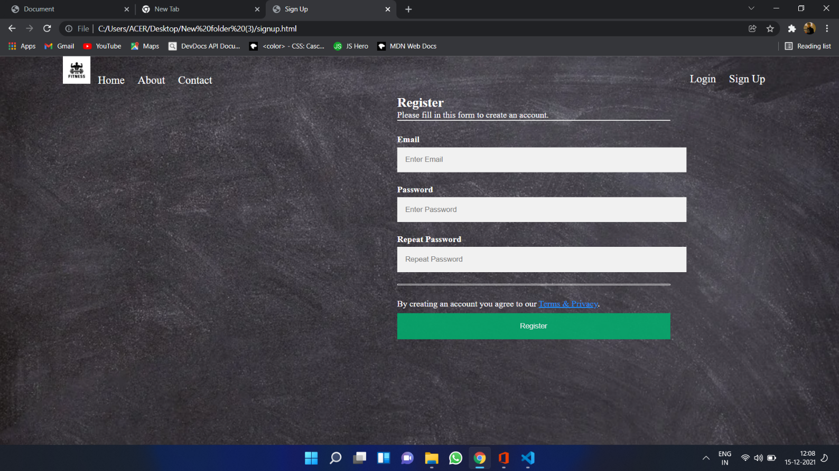

<!DOCTYPE html>

<html lang="en">

<head>

<meta charset="UTF-8">

<meta http-equiv="X-UA-Compatible" content="IE=edge">

<meta name="viewport" content="width=device-width, initial-scale=1.0">

<title>Sign Up</title>

<link rel="stylesheet" href="signup.css">

</head>

<body>

<nav class="right">

<ul>

<img src="logo.jpg" alt="logo" srcset="">

<li><a href="first.html">Home</a></li>

<li><a href="About.html">About</a></li>

<li><a href="contact">Contact</a></li>

<div class="left">

<li><a href="index.html">Login</a></li>

<li><a href="signup.html">Sign Up</a></li>

</div>

</ul>

<form action="action_page.php">

<div class="container">

<h1>Register</h1>

<p>Please fill in this form to create an account.</p>

<hr>

<label for="email"><b>Email</b></label>

<input type="text" placeholder="Enter Email" name="email" id="email" required>

<label for="psw"><b>Password</b></label>

<input type="password" placeholder="Enter Password" name="psw" id="psw" required>

<label for="psw-repeat"><b>Repeat Password</b></label>

<input type="password" placeholder="Repeat Password" name="psw-repeat" id="psw-repeat" required>

<hr>

<p>By creating an account you agree to our <a href="#">Terms & Privacy</a>.</p>

<button type="submit" class="registerbtn">Register</button>

</div>

</div>

</form>

</body>

</html>

# HOME:-

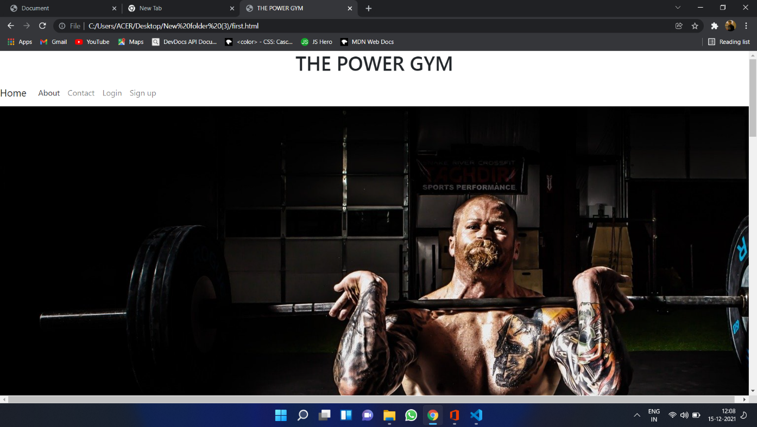

<!doctype html>

<html lang="en">

<head>

<meta charset="utf-8">

<meta name="viewport" content="width=device-width, initial-scale=1">

<link href="https://cdn.jsdelivr.net/npm/bootstrap@5.1.3/dist/css/bootstrap.min.css" rel="stylesheet" integrity="sha384-1BmE4kWBq78iYhFldvKuhfTAU6auU8tT94WrHftjDbrCEXSU1oBoqyl2QvZ6jIW3" crossorigin="anonymous">

<title>THE POWER GYM</title>

</head>

<body>

<h1 style="text-align: center;">THE POWER GYM</h1>

<nav class="navbar navbar-expand-lg navbar-light bg-light>

<div class="container-fluid">

<a class="navbar-brand" href="first.html">Home</a>

<button class="navbar-toggler" type="button" data-bs-toggle="collapse" data-bs-target="#navbarNav" aria-controls="navbarNav" aria-expanded="false" aria-label="Toggle navigation">

<span class="navbar-toggler-icon"></span>

</button>

<div class="collapse navbar-collapse" id="navbarNav">

<ul class="navbar-nav">

<li class="nav-item">

<a class="nav-link active" aria-current="page" href="about.html">About</a>

</li>

</li>

<li class="nav-item">

<a class="nav-link" href="contact.html">Contact</a>

</li>

<li class="nav-item">

<a class="nav-link" href="index.html">Login</a>

</li>

<li class="nav-item">

<a class="nav-link" href="signup.html">Sign up</a>

</li>

</ul>

</div>

</div>

</nav>

<div id="carouselExampleIndicators" class="carousel slide" data-bs-ride="carousel">

<div class="carousel-indicators">

<button type="button" data-bs-target="#carouselExampleIndicators" data-bs-slide-to="0" class="active" aria-current="true" aria-label="Slide 1"></button>

<button type="button" data-bs-target="#carouselExampleIndicators" data-bs-slide-to="1" aria-label="Slide 2"></button>

<button type="button" data-bs-target="#carouselExampleIndicators" data-bs-slide-to="2" aria-label="Slide 3"></button>

</div>

<div class="carousel-inner">

<div class="carousel-item active">

<img src="1.jpg" class="d-block w-70" alt="...">

</div>

<div class="carousel-item">

<img src="6.jpg" class="d-block w-70" alt="...">

</div>

<div class="carousel-item">

<img src="3.jpg" class="d-block w-70" alt="...">

</div>

</div>

<button class="carousel-control-prev" type="button" data-bs-target="#carouselExampleIndicators" data-bs-slide="prev">

<span class="carousel-control-prev-icon" aria-hidden="true"></span>

<span class="visually-hidden">Previous</span>

</button>

<button class="carousel-control-next" type="button" data-bs-target="#carouselExampleIndicators" data-bs-slide="next">

<span class="carousel-control-next-icon" aria-hidden="true"></span>

<span class="visually-hidden">Next</span>

</button>

</div>

</li>

</ul>

<div class="card-group">

<div class="card">

<img src="5.jpg" class="card-img-top" alt="...">

<div class="card-body">

<h5 class="card-title">THE FITNESS LEVEL</h5>

<p class="card-text">“The last three or four reps is what makes the muscle grow. ...

</p>

<p class="card-text"><small class="text-muted">Last updated 3 mins ago</small></p>

</div>

</div>

<div class="card">

<img src="6.jpg" class="card-img-top" alt="...">

<div class="card-body">

<h5 class="card-title">UNISEX GYM</h5>

<p class="card-text">You shall gain, but you shall pay with sweat, blood, and vomit.”</p>

<p class="card-text"><small class="text-muted">Last updated 3 mins ago</small></p>

</div>

</div>

<div class="card">

<img src="7.jpg" class="card-img-top" alt="...">

<div class="card-body">

<h5 class="card-title">Card title</h5>

<p class="card-text">This is a wider card with supporting text below as a natural lead-in to additional content. This card has even longer content than the first to show that equal height action.The successful warrior is the average man, with laser-like focus.’</p>

<p class="card-text"><small class="text-muted">Last updated 3 mins ago</small></p>

</div>

</div>

</div>

<H1>EQUIPMENTS</H1>

<div class="row row-cols-1 row-cols-md-2 g-4">

<div class="col">

<div class="card">

<img src="11.jpg" class="card-img-top" height="300px"alt="...">

<div class="card-body">

<h5 class="card-title">DUMBELLS</h5>

<p class="card-text">dumbbells are weights created in a dumbbell shape. Inexpensive varieties consist of cast iron, sometimes coated with rubber or neoprene for comfort, and even cheaper versions consist of a rigid plastic shell that is filled with concrete.

</p>

</div>

</div>

</div>

<div class="col">

<div class="card">

<img src="9.jpg" class="card-img-top" height="300px" alt="...">

<div class="card-body">

<h5 class="card-title">TREADMILL</h5>

<p class="card-text">PowerMax Fitness TDM-98 Motorized Treadmill. ...

Healthgenie 3911M Motorized Treadmill. ...

Lifelong FitPro LLTM09 Motorized Treadmill. ...

Cockatoo CTM-04 Motorized Treadmill. ...

MAXPRO PTM405 Motorized Treadmill. ...

Fitkit FT200 Series Motorized Treadmill.</p>

</div>

</div>

</div>

<div class="col">

<div class="card">

<img src="10.jpg" class="card-img-top" height="300px"alt="...">

<div class="card-body">

<h5 class="card-title">Cardio</h5>

<p class="card-text">Cardio is defined as any type of exercise that gets your heart rate up and keeps it up for a prolonged period of time. Your respiratory system will start working harder as you begin to breathe faster and more deeply. ... The physical and mental benefits of this type of exercise are seemingly endless</p>

</div>

</div>

</div>

<div class="col">

<div class="card">

<img src="11.jpg" class="card-img-top" height="300px" alt="...">

<div class="card-body">

<h5 class="card-title">Cardio</h5>

<p class="card-text">Cardio is defined as any type of exercise that gets your heart rate up and keeps it up for a prolonged period of time. Your respiratory system will start working harder as you begin to breathe faster and more deeply. ... The physical and mental benefits of this type of exercise are seemingly endless</p>

</div>

</div>

</div>

</div>

<!-- Footer -->

<footer class="page-footer font-small blue">

<!-- Copyright -->

<div class="footer-copyright text-center py-3">© 2020 Copyright:

</div>

<!-- Copyright -->

# ABOUT:-

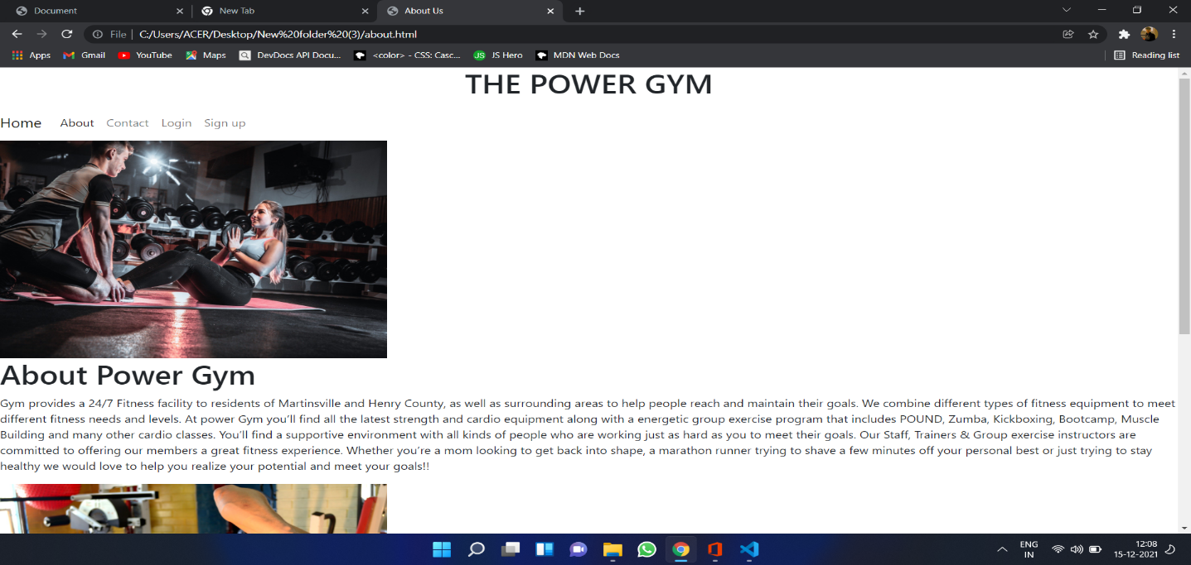

<!doctype html>

<html lang="en">

<head>

<!-- Required meta tags -->

<meta charset="utf-8">

<meta name="viewport" content="width=device-width, initial-scale=1">

<link href="https://cdn.jsdelivr.net/npm/bootstrap@5.1.3/dist/css/bootstrap.min.css" rel="stylesheet" integrity="sha384-1BmE4kWBq78iYhFldvKuhfTAU6auU8tT94WrHftjDbrCEXSU1oBoqyl2QvZ6jIW3" crossorigin="anonymous">

<title>About Us</title>

<style>

</style>

</head>

<body>

<body >

<h1 style="text-align: center;">THE POWER GYM</h1>

<nav class="navbar navbar-expand-lg navbar-light bg-light>

<div class="container-fluid">

<a class="navbar-brand" href="first.html">Home</a>

<button class="navbar-toggler" type="button" data-bs-toggle="collapse" data-bs-target="#navbarNav" aria-controls="navbarNav" aria-expanded="false" aria-label="Toggle navigation">

<span class="navbar-toggler-icon"></span>

</button>

<div class="collapse navbar-collapse" id="navbarNav">

<ul class="navbar-nav">

<li class="nav-item">

<a class="nav-link active" aria-current="page" href="about.html">About</a>

</li>

</li>

<li class="nav-item">

<a class="nav-link" href="contact.html">Contact</a>

</li>

<li class="nav-item">

<a class="nav-link" href="index.html">Login</a>

</li>

<li class="nav-item">

<a class="nav-link" href="signup.html">Sign up</a>

</li>

</ul>

</div>

</div>

</nav>

<img src="3.jpg" class="img-fluid" width="499" height="253" alt="...">

<h1>About Power Gym</h1>

<p>

Gym provides a 24/7 Fitness facility to residents of Martinsville and Henry County, as well as surrounding areas to help people reach and maintain their goals. We combine different types of fitness equipment to meet different fitness needs and levels.

At power Gym you’ll find all the latest strength and cardio equipment along with a energetic group exercise program that includes POUND, Zumba, Kickboxing, Bootcamp, Muscle Building and many other cardio classes. You’ll find a supportive environment with all kinds of people who are working just as hard as you to meet their goals.

Our Staff, Trainers & Group exercise instructors are committed to offering our members a great fitness experience. Whether you’re a mom looking to get back into shape, a marathon runner trying to shave a few minutes off your personal best or just trying to stay healthy we would love to help you realize your potential and meet your goals!!

</p>

<img src="10.jpg" class="img-fluid" width="499" height="253" alt="...">

<br><br><br><br><br><br><br><br><br><br>

<footer class="page-footer font-small blue">

<!-- Copyright -->

<div class="footer-copyright text-center py-3">© 2020 Copyright:

</div>

<!-- Copyright -->

</footer>

</body>

</html>

# CONTACT US:-

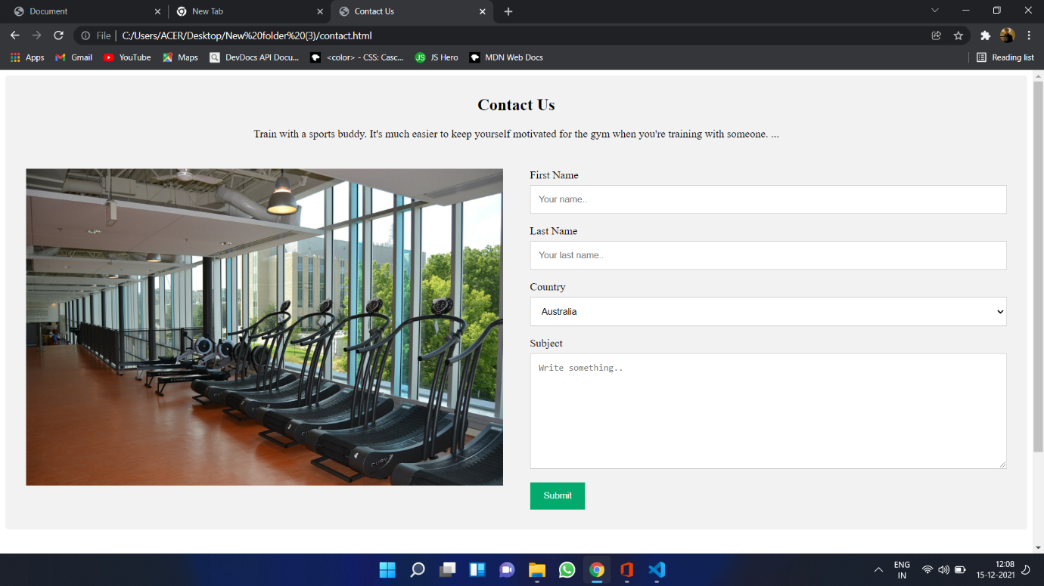

<!DOCTYPE html>

<html lang="en">

<head>

<meta charset="UTF-8">

<meta http-equiv="X-UA-Compatible" content="IE=edge">

<meta name="viewport" content="width=device-width, initial-scale=1.0">

<link rel="stylesheet" href="contact.css">

<title>Contact Us</title>

</head>

<body>

<div class="container">

<div style="text-align:center">

<h2>Contact Us</h2>

<p>Train with a sports buddy. It's much easier to keep yourself motivated for the gym when you're training with someone. ...</p>

</div>

<div class="row">

<div class="column">

<img src="9.jpg" style="width:100%">

</div>

<div class="column">

<form action="/action_page.php">

<label for="fname">First Name</label>

<input type="text" id="fname" name="firstname" placeholder="Your name..">

<label for="lname">Last Name</label>

<input type="text" id="lname" name="lastname" placeholder="Your last name..">

<label for="country">Country</label>

<select id="country" name="country">

<option value="australia">Australia</option>

<option value="canada">Canada</option>

<option value="usa">USA</option>

</select>

<label for="subject">Subject</label>

<textarea id="subject" name="subject" placeholder="Write something.." style="height:170px"></textarea>

<input type="submit" value="Submit">

</form>

</div>

</div>

</div>

<br><br><br><br><br><br><br><br><br><br>

<footer class="page-footer font-small blue">

<!-- Copyright -->

<div class="footer-copyright text-center py-3">© 2020 Copyright:

</div>

</footer>

</body>

</html>

**CSS CODE:-**

*{

margin:0;

padding: 0;

}

body{

background: url(dumbbell.jpg) no-repeat;

background-size: 100%,100%;

}

img{

height:100px;

width:100px;

}

.right li{

display: inline;

padding: 30px 10px;

}

.right li a{

text-decoration: none;

font-size: 20px;

color: white;

}

.left{

float:right;

padding: 30px 10px;

}

li:hover{

color:orange;transition: background-color .5s;

}

.container{

padding-left: 1px;

margin: top 2px;

width: 500px;color:white;

float: right;

}

.container input{

margin-top:50px;

padding:5px;

width:300px

}

.btn{

margin-top:10px;

margin-left:220px;

padding:7px;

color: white;

border-radius:8px;

}

# FUTURE WORK

There is lot of work to do in our website. As in this project we work only with Front-end (HTML+CSS). In Future we can modify this website by using JavaScript, Angular, React and various web based Database.The user’s details are maintained confidential because it maintains a separate account for each user. An id and password is provided for each user.

# CONCLUSION

Going to the gym will benefit you in many ways. People should take advantage of going to the gym when they can. It helps you to feel more relaxed and better about yourself. You’re taking the initiative to do something for yourself, your body, and your health. Whether your goal be to relieve some stress and anxiety, to get in better shape, or to encourage your overall health, the gym is the place to go. No matter how young or old you are, it’s still a great place to stay fit and healthy.